MATHEMATICS LECTURES BY
MANISH KALIA
(B.TECH Delhi College of Engineering)
Lecture………date…………

 Exercise1.1
Q1 Find the degree measure corresponding to the following radian measures
- 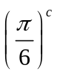
- 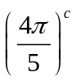
- 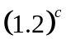
Q2 Express 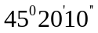 in radian measure (π=3.1415)
Q3 The angles of triangle are in the ratio 3:4:5.Find the smallest angle in degrees and the greatest angle in radians
Q4 Find the angle between the hour-hand and the minute hand in circular measure at half past 4?
Q5 If q and r denote respectively the degree measure and the radian measure of the same angle,prove that 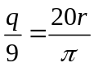
Q6 The angles in a triangle are in A.P and the ratio of the smallest angle in degrees to the greatest angle in radians is

60:π.Find the angle of triangle in degrees and radians.
Q7 The minute hand of a watch is 1.5 cm long. How far does its tip move in 40 minutes? (Use π = 3.14). [NCERT]
Q8 If the arcs of the same lengths in two circles subtend angles 65°and 110°
at the centre, find the ratio of their radii [NCERT]
Q9 Find the radius of the circle in which a central angle of 45º intercepts an arc 132 cm(use π=22/7)

